Seadimo Bugqwangu
JSONPlaceholder
API Security risk analysis report

Table of Contents
1. Introduction
2. Scope of Assessment
3. Tools Used
4. Methodology
5. Findings
6. Conclusion
7. References

Introduction
This report presents a comprehensive security assessment of the JSONPlaceholder API, a publicly accessible RESTful service commonly used for testing and prototyping. The purpose of this analysis is to evaluate the API’s design and identify potential security weaknesses that could pose risks if present in a production environment.
APIs are a critical component of modern software architecture, enabling communication between systems and services. However, poorly secured APIs are a leading cause of data breaches and unauthorized access. As such, assessing API security is essential to ensure the confidentiality, integrity, and availability of data.
The assessment was conducted using Postman to simulate HTTP requests and observe API responses across multiple endpoints. The analysis focuses on identifying vulnerabilities such as lack of authentication, insecure direct object references (IDOR), and excessive data exposure. Findings are evaluated in alignment with industry best practices and principles outlined by the OWASP API Security Top 10.
Although JSONPlaceholder is intentionally designed as an open and non-secure API for learning purposes, this report treats the system as if it were a real-world application in order to demonstrate practical security analysis techniques and highlight critical areas for improvement.

Scope of Assessment
This assessment focuses on publicly accessible endpoints of the JSONPlaceholder API. The analysis is limited to non-intrusive testing methods, including observation of responses, endpoint manipulation, and parameter testing. No attempts were made to exploit or disrupt the API, in accordance with ethical security testing practices.

Tools Used
- Postman – sending HTTP requests and analysing API responses
- Web Browser(Google Chrome) – verifying endpoint behaviour
- JSONPlaceholder API – target system for the security assessment

Methodology
- Sent GET requests to multiple API endpoints
- Analysed HTTP responses, status codes, and returned data
- Tested endpoint accessibility without authentication
- Manipulates request parameters to observe API behaviour
- Captured screenshots as supporting evidence
The approach followed a black-box testing methodology, simulating the perspective of an external attacker with no prior access or credentials

Findings
Finding 1: Unauthenticated API Access
Description: The API allows unrestricted access to multiple endpoints without requiring authentication or authorization.
Evidence: Requests to “/users”, “/posts”, and “/comments” endpoints returned data with a “200 OK” response without any API key or login credentials.
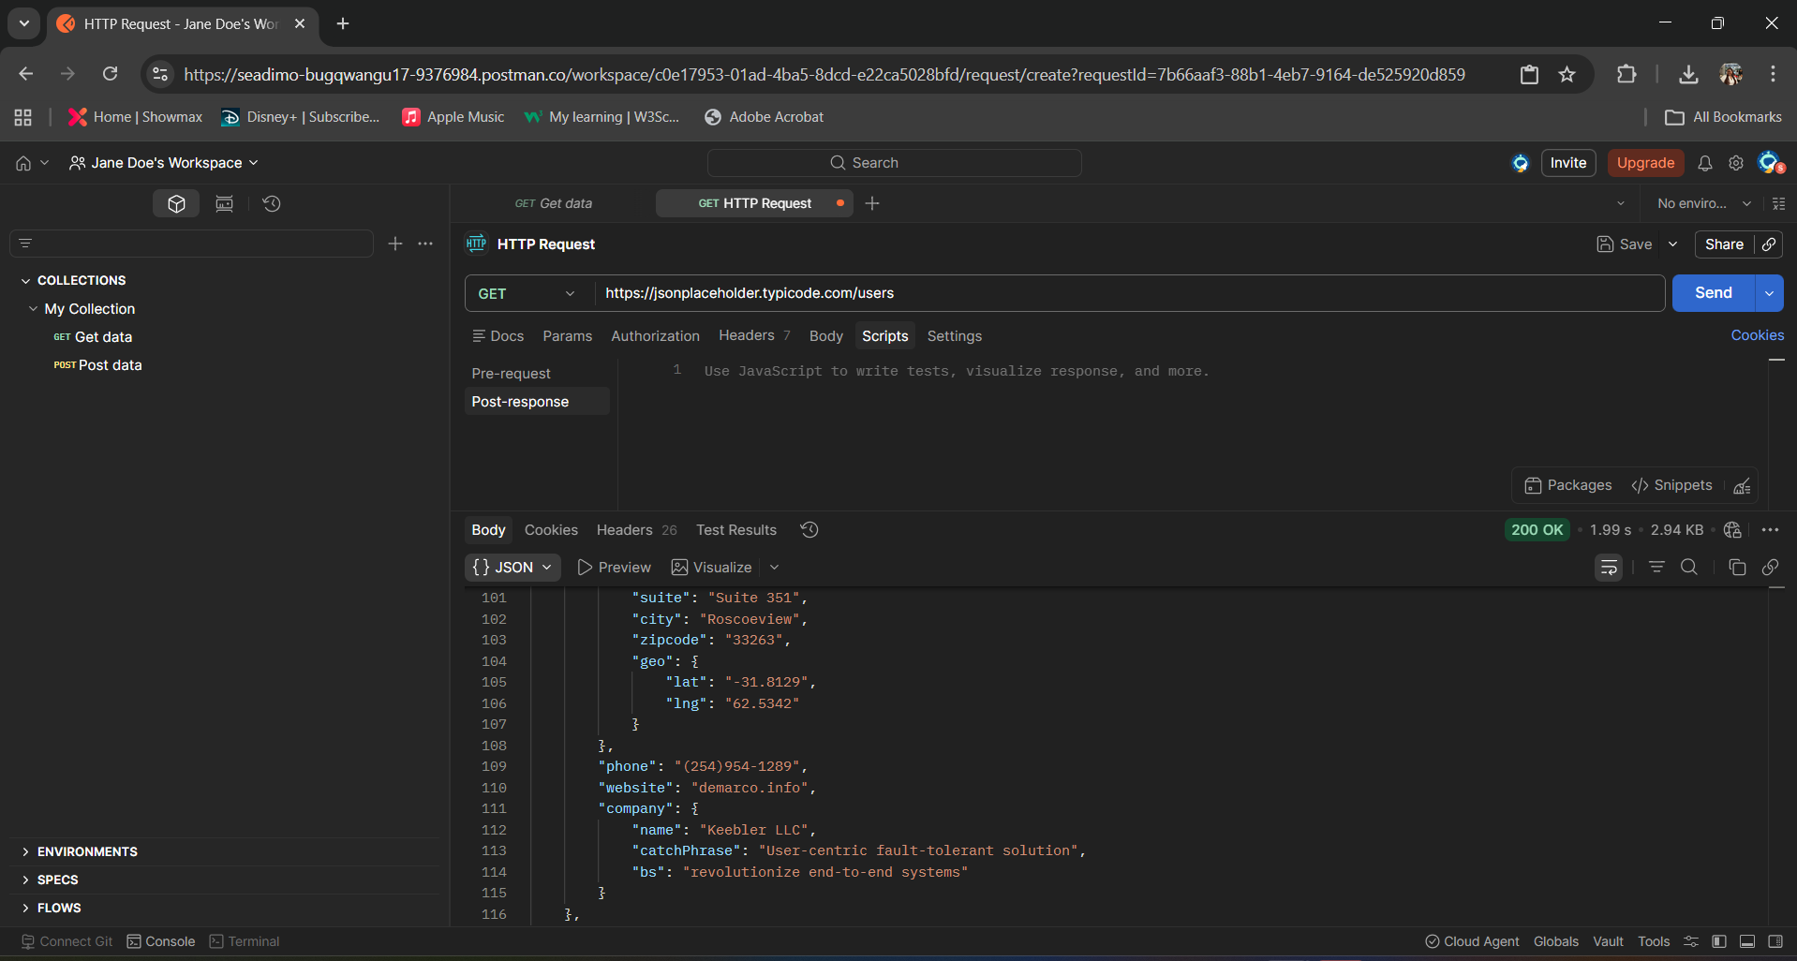
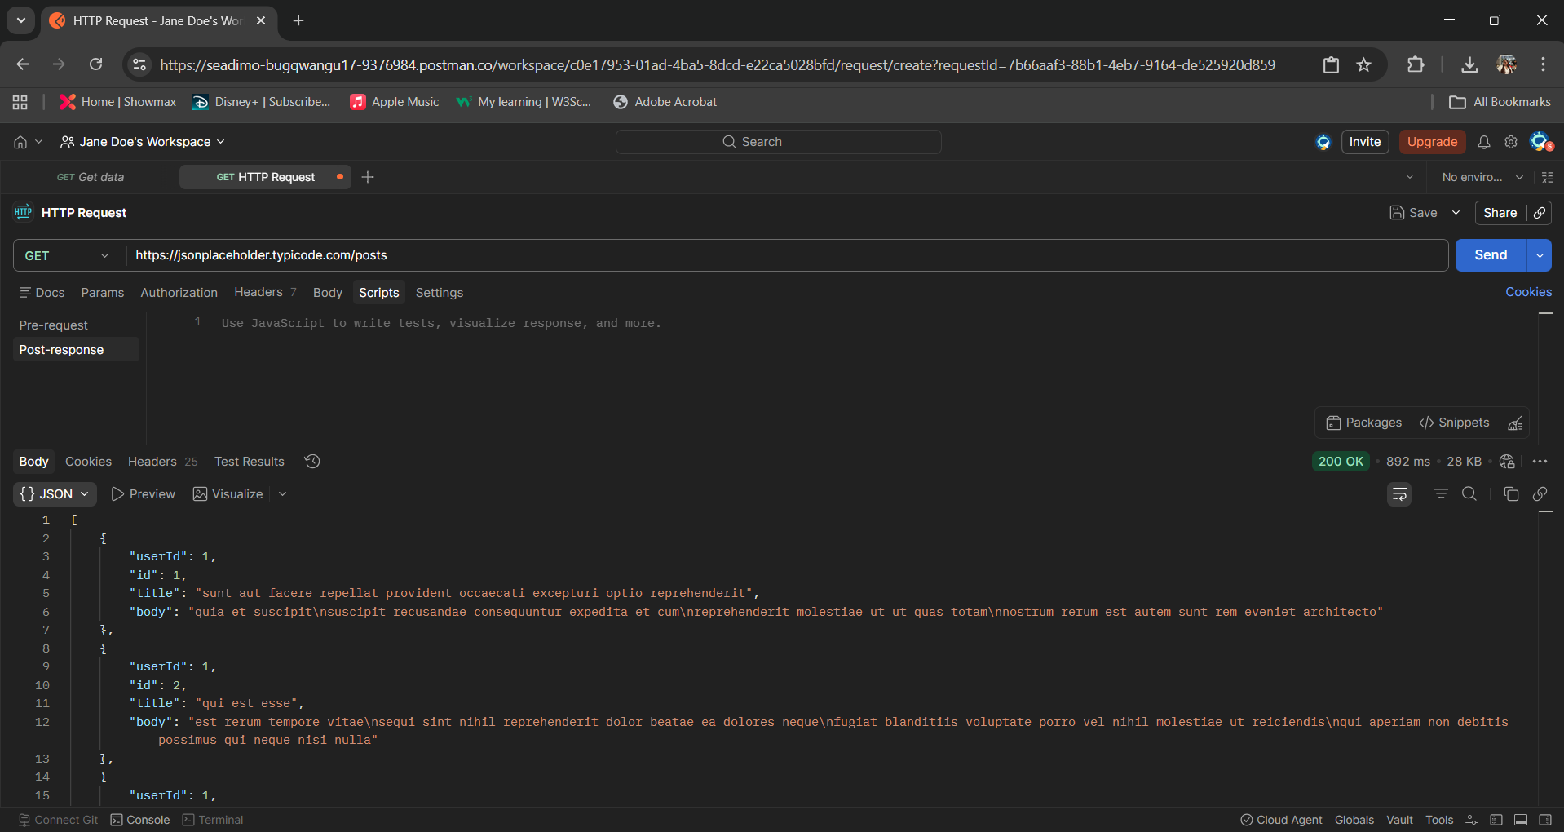
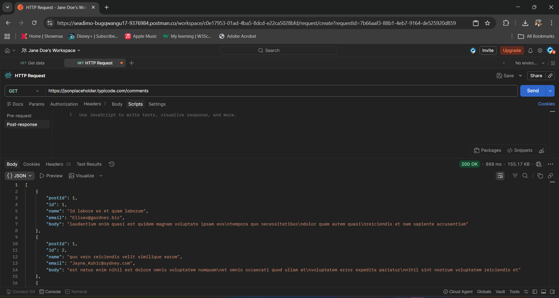

Risk Level: Medium
Impact: Unauthorized users can access data freely, which could lead to data exposure in real-world applications.
Recommendations: Implement authentication mechanisms such as API keys, OAuth tokens, or JWT-based authentication to restrict access.

Finding 2: Insecure Direct Object Reference(IDOR)
Description: The API allows to specific user data by modifying the user ID in the endpoint URL.
Evidence: Accessing “/users/1”, “/users/2”, and other IDs returned user data without any authorization checks.
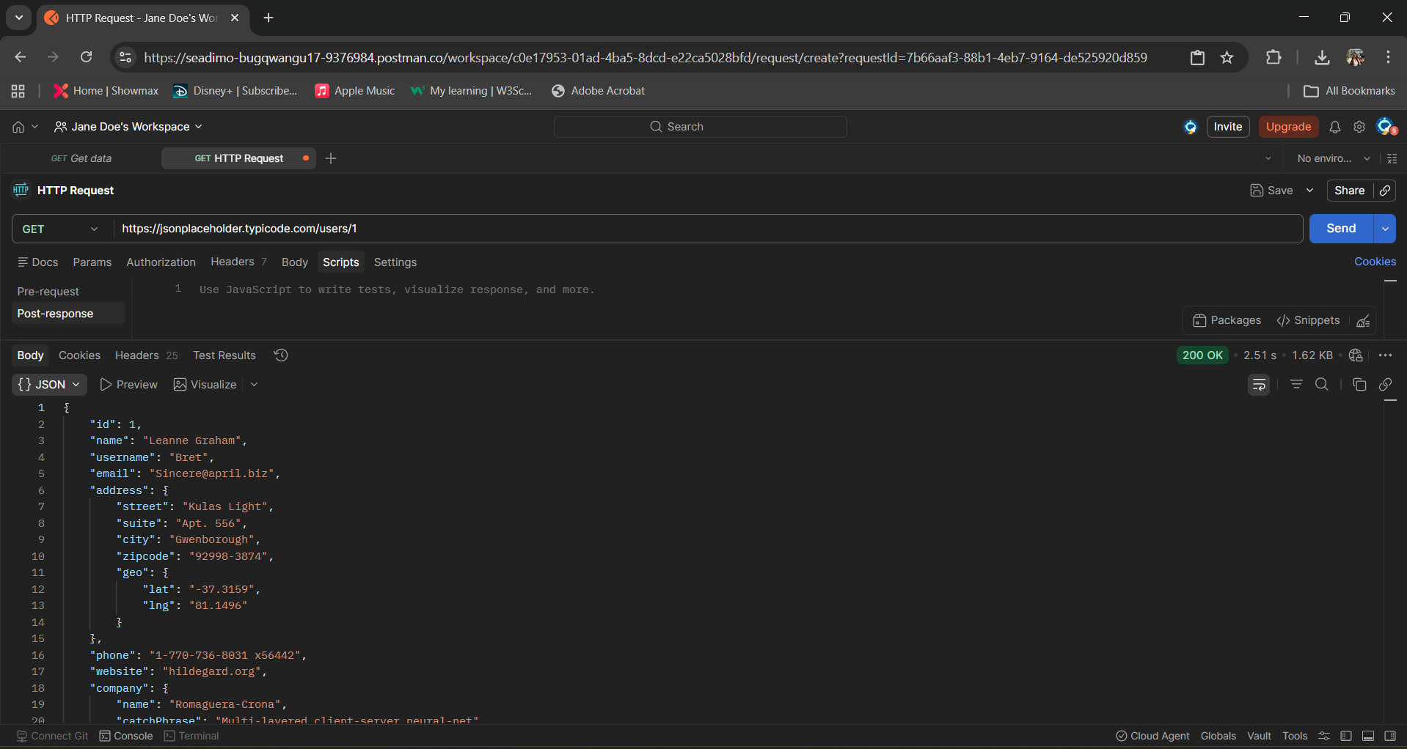

Risk Level: High-Due to the potential for unauthorized access to user-p\specific data through predictable object identifiers.
Impact: Attackers could enumerate user IDs and extract sensitive information from other users.
Recommendation: Implement proper authorization checks to ensure users can only access their own data.

Finding 3: Excesssive Data Exposure
Description: The API returns detailed user information, including email and address data, which may not necessary for all use cases.
Evidence: The “/users”” endpoint exposes multiple fields such as email, address, and company details.


Risk Level: Medium
Impact: Sensitive data exposure increases the risk of privacy violations and dat misuse.
Recommendation: Limit the data returned by the API to only what is necessary for the client.

Conclusion
This security assessment identified several critical API security weaknesses, including unrestricted access to endpoints, potential Insecure Direct Object Reference(IDOR) vulnerabilities, and excessive exposure of user data. While these issues are expected within a mock API environment, they reflect common real-world security misconfigurations that can lead to serious consequences if left unaddressed.
The absence of authentication mechanisms allows unrestricted access to sensitive data, significantly increasing the risk of unauthorized data exposure. Additionally, the ability to manipulate object identifiers without validation highlights the importance of implementing robust authoriation controls. The exposure of detailed user iinformation further emphasizes the need for data minimization practices in API design.
These findings reinforce the importance of secure API development practices, including strong authentication and authorization controls, proper input validation, and limiting data exposure. Organizations must proactively assess and secure their APIs to mitigate potential attack vectors and ensure compliance with modern security standards.
Overall, this analysis demonstrates the critical role of API security in safeguarding digital systems and provides practical insights into identifying and mitigation common vulnerabilities in API architectures.

References
1. OWASP Foundation. OWASP API Security Top 10. Available at: https://owasp.org/www-project-api-security/
2. JSONPlaceholder. Fake Online REST API for Testing and Prototyping. Available at: https://jsonplaceholder.typicode.com/
3. Postman. API Platform for Building and Using APIs. Available at: https://www.postman.com/

